LBSC708a Final Exam Section 0101 Fall 2000

You have 3 hours to complete this exam (it should take less than that).
- You may use one page of handwritten or typed notes.
- You may use a calculator if you brought one.
- You may use any program on the IPL computers.
- You may NOT use any files that you have previously created (whether in the teaching theater, on WAM, or elsewhere).
- Also, you may NOT communicate with any other person during this exam, (except the professor or the GA), either in person or using an electronic means.
- You may NOT browse the Web except in the context of questions that explicitly require you to do that.

As strategies for completing the questions on this exam, please keep in mind the following:
- If you find a question ambiguous, please explain your confusion.
- You are more likely to get partial credit for a wrong answer if you show your work.
- Be careful not to get carried away and run over the time limit. In other words, plan ahead.
- Be sure to save your work frequently.

Please email a copy of your exam to rba@glue.umd.edu when you finish. In case we have some trouble recovering your files, it is a good idea for you to keep a back-up copy. You can do this on a floppy disk, by ftp-ing the files to your WAM account, and/or by emailing yourself a copy.

Score Summary (for use by grader)
Question | Possible points  (Project Students) | Possible points  (Algorithm Students) | Actual points
1 | 20 | 20
2 | 30 | 30
3 | 30 | 30
4 | 20 | 20
5 (algorithms) |  | 40
TOTAL | 100 | 140

BEGIN 708a FINAL

NAME:
Email-Address:

- (20 points) – Short Definitions (1-2 sentences):

- Histogram
- Hidden-Markov Models
- Harvest model
- Shape coding
- Average precision

- (30 points) Short Discussion (2-3 sentences):

a. What are eigenfaces? How are they related to LSI?
- Explain the image at the end of this exam. What is shown at the top? What do the sliders do? What does this particular image show?
- Describe a procedure for automatic detection of scene and shot boundaries.
- What is relevance feedback? Explain some issues about it with respect to user interaction and the way it is calculated.
- What is “adaptive filtering”? What are some techniques for it?
- Briefly describe at least two fundamental strategies for cross-language information retrieval.

- (30 points) Longer Discussion (about 2 paragraphs each) and Short Problems

- Give an example of how the vector model may be applied in multimedia retrieval (beyond its use for text retrieval).
- Describe Bayes Rule and explain at least one example of how it can be applied for text processing and retrieval.
- Describe some procedures you might use in a music browsing and retrieval system.

- (20 points) Thought question:
What are some of the obstacles to developing high quality speech recognition? If we succeed in doing that, how might it change the nature of information systems and libraries. (Note, for the last part of this question, there is no “right” answer but you should emphasize principles you have learned in this class.)
.

- Algorithms Students Only:
a. (20 points) Explain what an “R-tree” is and how it is used. Give an example.
- (10 points) Describe what is meant by “text coding”. Describe the advantages of Huffman coding and give an example of it.
- (10 points) Explain some procedures for image queries and retrieval. For example, describe the procedures used in Blob World.

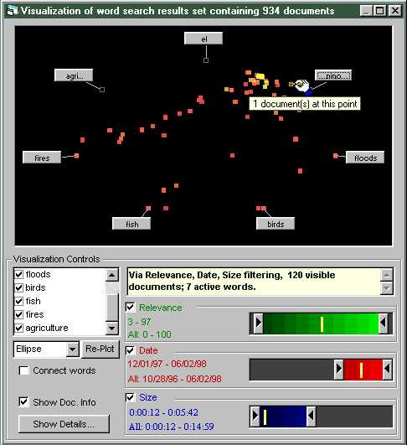

END 708a FINAL

